Progress Report For the Month Of January



Academic Session 2016- 18

School of Computer Applications

Online Job Portal

Submitted by Submitted to
Neha Ms. Ramandeep Kaur
(11605084)

INTRODUCTION OF PROJECT

This project is aimed at developing an online search Portal for the Placement Details for job seekers. The system is an online application that can be accessed throughout the organization and outside as well with proper login provided. This system can be used as an Online Job Portal for job seekers. Job Seekers logging should be able to upload their information in the form of a CV. Visitors/Company representatives logging in may also access/search any information put up by Job aspirants.

PURPOSE OF THE PROJECT

This system can be used as an Online Job Portal for the Placements providing to the un employees who are seeking for a job placement. Job Seeker logging into the system and he can should be able to upload their information in the form of a CV. Visitors/Company representatives logging in may also access/search any information put up by Job Seeker.

NUMBER OF MODULES
The system after careful analysis has been identified to be presented with the following modules:
The modules involved are:
• Admin
• Job Seeker
• Job Provider
• Notification
• Search
• Report
• Authentication
Admin
In this module Admin will add all the qualifications, skill, experience, city, state, country and update and delete information about the job provider or job seeker he can also search for the job seeker and he can send mail to offer the job to job seeker and he can also see the jobs add by the job provider.

Job Seeker
In this module Job Seeker register him self and upload his resume and fill the profile give by admin and after login he will search for the job on various conditions and he can change his profiles and resume and he can apply for the jobs based on various conditions. He can see the response of the company and he can call the company person for the interview.

Job provider
In this module Job Provider register him self and his company and after login he will add new job and he can search for the job seekers on various condition and he can offer the job to job seeker according to the job profile and he can also see the response from the job seekers and send the mail.

Notification
In this module admin and job provider send the notification to the job seeker in the form of email.

Reports
This module contains all the information about the reports generated by the admin based on the particular job seeker, particular job provider, all job seeker and job provider, all jobs generated by the job providers.

Authentication
This module contains all the information about the authenticated user. User without his username and password can’t enter into the login if he is only the authenticated user then he can enter to his login.

Technology Used
Front End: Html,css,java script, jquery,bootstrap3
Back End: PHP
Team size
2 members and I will work on front end as well as backend
Hardware requirements
RAM | 512MB and above
Hard Disk | 30MB and above
Processor | Pentium– III processor and above

Software requirements:
Operating System | Windows NT /95/98/XP/7/8/10and above
Web Server | Wampserver
Programming  Softwares | HTML/JavaScript/Css/bootstrap/jquery
Browser | Internet Explorer Version 5.0/0.,/ Mozilla Firefox 12.0/Google Chrome

Task performed in project till date
Flow of the project: Design some part of the project
- In my project that is, “Online Job Portal “ I will firstly design my logo.
- Then I will create my home page with the help of bootstrap,css,html,javascript.
- My home page is fully responsive that will open in windows and Android both.

- I also design my First page

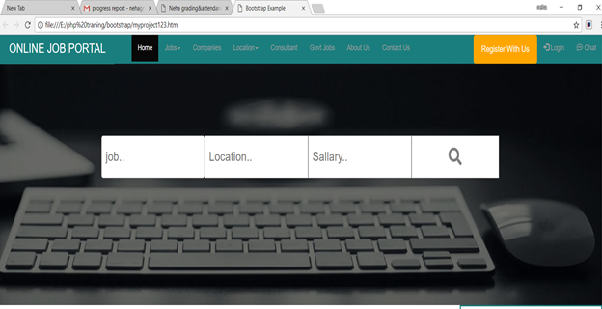

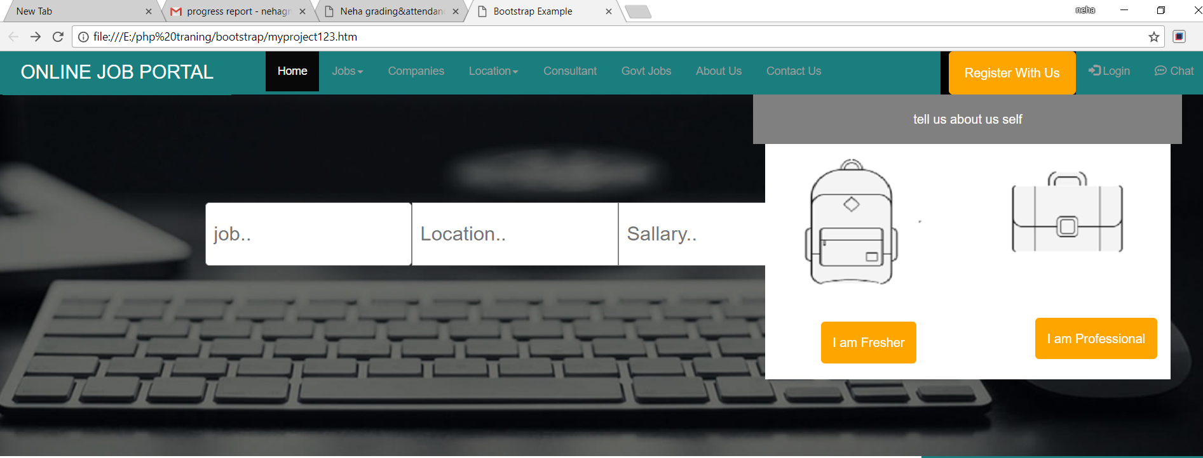

- I also design my User login page .

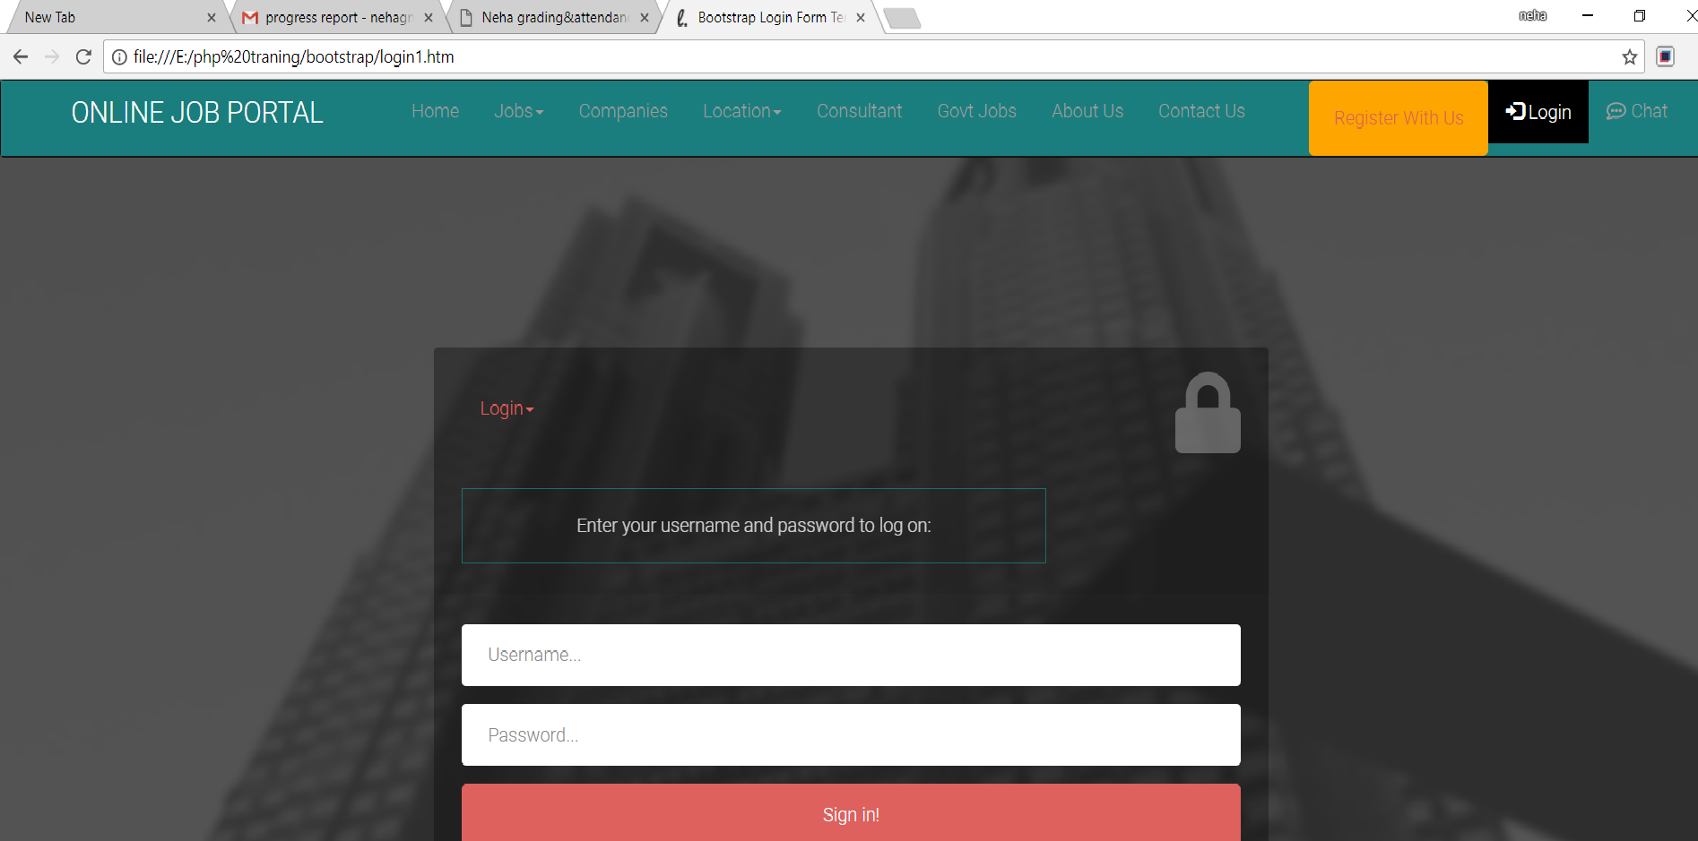

- I also Design my Register Page
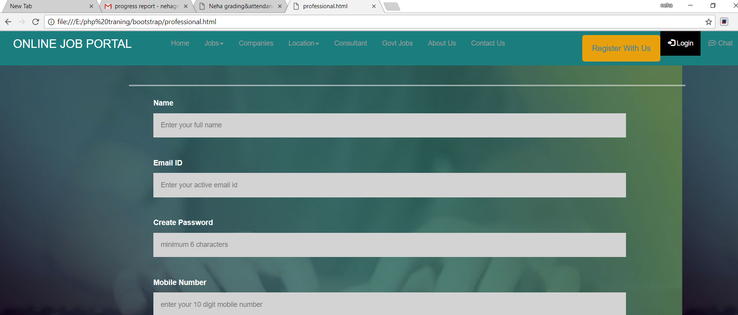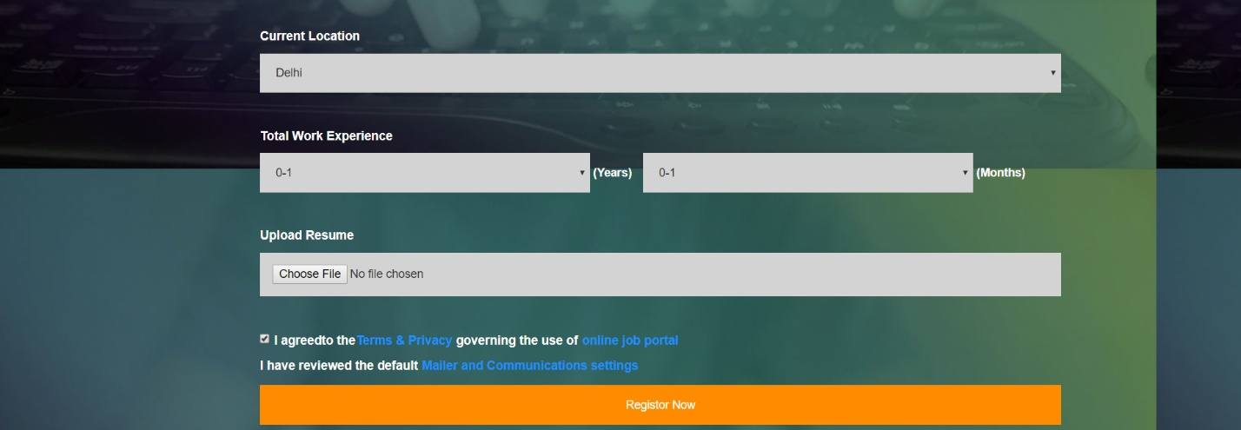

- I also Design My Companies Page.
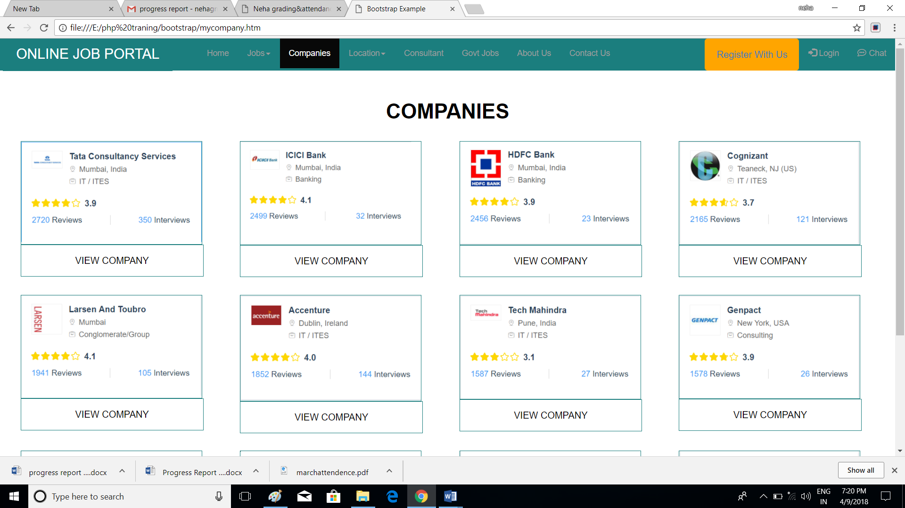

- I had done Design my other Pages also
- And my 85% of Designing is completed.
- I also started my data base connectivity part.
- I have done my Register Page connectivity and some other page also.
Next month plan
Not yet plan.

